Eagle One Golden Rule Award 2007
The Golden Rule Awards honors car clubs for outstanding achievement in community service. It is presented by Eagle One, which markets a complete line of premium appearance care products.
The Award is presented to the car club judged to have the most outstanding community service program in the West, Midwest, North, and South Regions of the USA. This award is considered to be the most prestigious award offered and therefore sought after by car clubs throughout the USA.
Eagle One and Valvoline will make a combined cash donation of $750.00 to a charitable cause selected by each of the four winning clubs. In addition, the four winning clubs will receive a custom-designed award, a generous supply of Eagle One and Valvoline products for fund-raising events and publicity in leading enthusiast magazines and local papers.
TEAM SKC was notified by phone January 24, 2007, that we are the winners of this year’s award for the Southern Region! A copy of the Official Letter was received on January 31, 2007.
Since the members of the Southern Knights Cruisers work to help Kids each year, the club requested the $750.00 be sent to the Victory Junction Gang Camp, as our charity of choice. This will help kids in North Carolina and Virginia.
The photo that Eagle One will use to be released to magazines, newspapers, etc. is below. We certainly thank the members that braved the cold weather to meet at Richard Bland College for this photo shoot. It was only 35 degrees, with a wind chill of 23-25, the day the photo was taken. We also want to thank Dr. James McNeer, President of the College, and the college security personnel for allowing us to use the beautiful campus grounds.
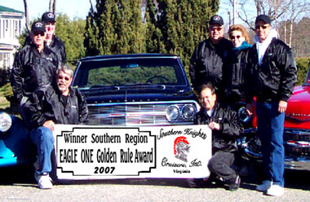
CONGRATULATIONS TO ALL CLUB MEMBERS WHO WORKED SO VERY HARD IN 2006, NOT FOR THE RECOGNITION, BUT TO HELP THOSE LESS FORTUNATE THAN OURSELVES!
~~~~ WAY TO GO GANG! ~~~~

We certainly want to thank Eagle One & Valvoline for all they do to support and promote all the automotive hobbyists events. And especially for making 1st Class Products that automotive hobbyists can trust to protect their investments. These have been tested and remain the best on the market that money can buy.
Check out all Eagle One Products and more on their website at www.eagleone.com

As most of you know, it has always been our club’s policy not to accept any recognition or awards for the charity work we do. We have made an exception in the case of the Eagle One Golden Rule Award for a couple of reasons:
1) The award comes with a check for $750.00, which we are sending to the Victory Junction Gang Camp to help kids in North Carolina and Virginia.
2) This award is being accepted on behalf of our loyal sponsors and participants that support all of our events. We acknowledge without YOUR continued support, we could not continue to help those less fortunate than ourselves. Because of you, we still believe in miracles.
Thank you for helping us make "Miracles Happen!"

